**PORTFOLIO**

**INDEX**

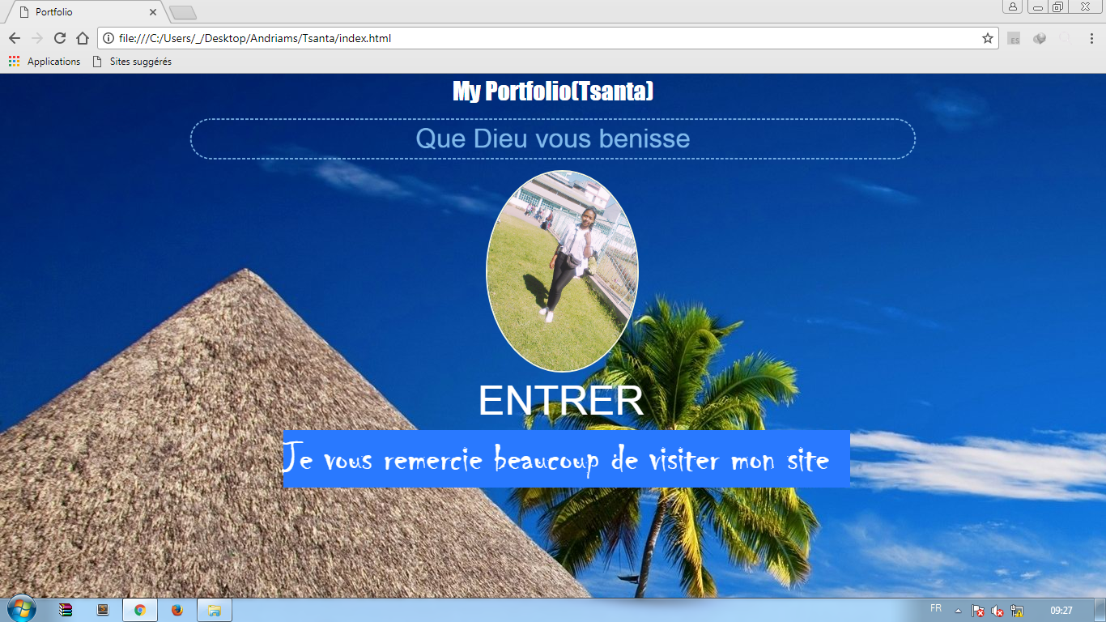

**CODE**

**<! DOCTYPE html>**

**<Html>**

**<Head>**

**<Meta Charest="utf-8">**

**<Title>Portfolio</title>**

**<link rel="stylesheet" type="text/css" href="assets/css/bootstrap.min.css">**

**<link rel="stylesheet" type="text/css" href="assets/css/style.css">**

**<link rel="stylesheet" type="text/css" href="assets/css/animate.css">**

**</head>**

**<Body>**

**<div id="test"> My Portfolio (Tsanta) </div>**

**<div class="tt"> Que Dieu vous bénisse </div>**

**<div id="eee">**

**<div id="sary"><img class="ooo" src="./assets/img/Tsanta.jpg"></div>**

**</div>**

**<div class="cont">**

**<a href="page1.html" class="contenue">ENTRER</a>**

**<div class="merci">Je vous remercie beaucoup de visiter mon site</div>**

**</body>**

**</html>**

**NB:**

**1) Pour préparer cette portfolio : on utilise bootsrap et animate pour faire l'animation et pour faciliter le travail.**

**2) Style : pour faire tous les styles dans une autre feuille.**

**PAGE1**

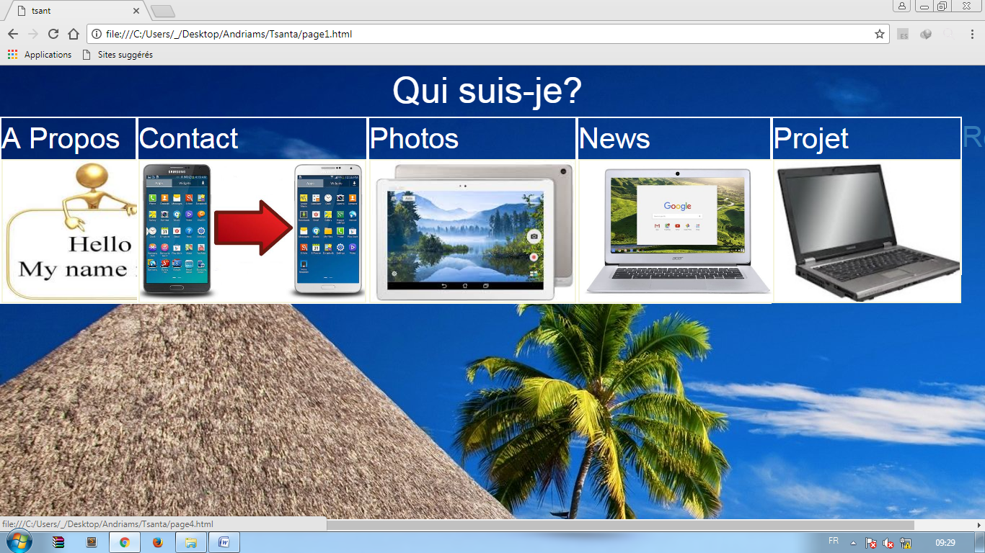

**CODE**

**<! DOCTYPE html>**

**<Html>**

**<Head>**

**<Meta charset="utf-8">**

**<title>tsanta</title>**

**<link rel="stylesheet" type="text/css" href="assets/css/bootstrap.min.css">**

**<link rel="stylesheet" type="text/css" href="assets/css/style.css">**

**</head>**

**<body>**

**<div class="noum"> Qui suis-je? <br></div>**

**<div class="NN">**

**<div id="jj">A Propos<a href="page3.html" class="contt"><img src=".\assets\img\pp.jpg"></a></div><br>**

**<div id="rr">Contact<a href="page2.html" class="contti"> <img src=".\assets\img\findd.jpg"></a></div><br>**

**<div id="kk">Photos<a href="page4.html" class="conttin"> <img src=".\assets\img\tabb.jpg"></a></div><br>**

**<div id="new">News<a href="page6.html" class="contt"> <img src=".\assets\img\di.jpg"></a></div>**

**<div id="ff">Projet<a href="page5.html" class="cct"> <img src=".\assets\img\ordi.jpg"></a></div>**

**<div class="rree"><div id="ret"><a href="index.html">Retour</a></div></div>**

**</Div>**

**</body>**

**</Html>**

**NB:**

**Dans cette page, on utilise toujours du boostrap pour faciliter le travail.**

**Et pour faire ce menu, on fait dans un même div ces 5 menus pour faciliter le travail surtout dans les feuilles de style.**

**Exemple:**

**<div class="NN">**

**Balises des 5 menus**

**</div>**

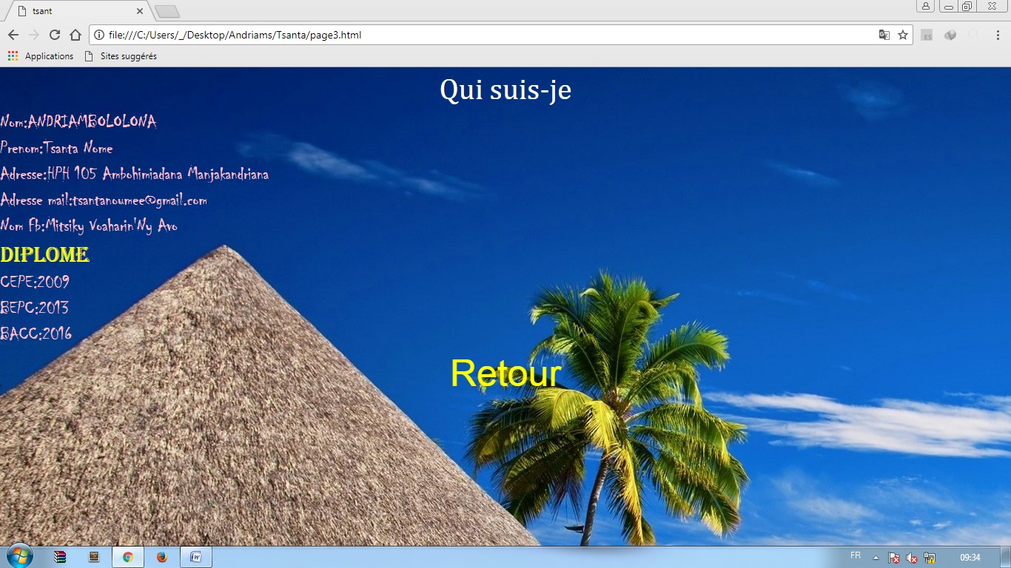

CODE

<! DOCTYPE html>

<Html>

<Head>

<Meta charset="utf-8">

<Title>tsant</title>

<link rel="stylesheet" type="text/css" href="assets/css/bootstrap.min.css">

<link rel="stylesheet" type="text/css" href="assets/css/style.css">

</head>

<Body>

<div class="qq"> Qui Suis -je</div>

<div class="zah">Nom: ANDRIAMBOLOLONA<br>Prenom: Tsanta Nome<br>Adresse: HPH 105 Ambohimiadana

<Br>Adresse mail:tsantanoumee@gmail.com<br>Nom Fb:Mitsiky Voaharin'Ny Avo</div>

</div>

<div class="meme">Diplome</div>

<div class="ddp">CEPE: 2009<br>BEPC:2013<br>BACC:2016</div>

<a href="page1.html"><div id="retu">Retour</div></a>

</body>

</html>

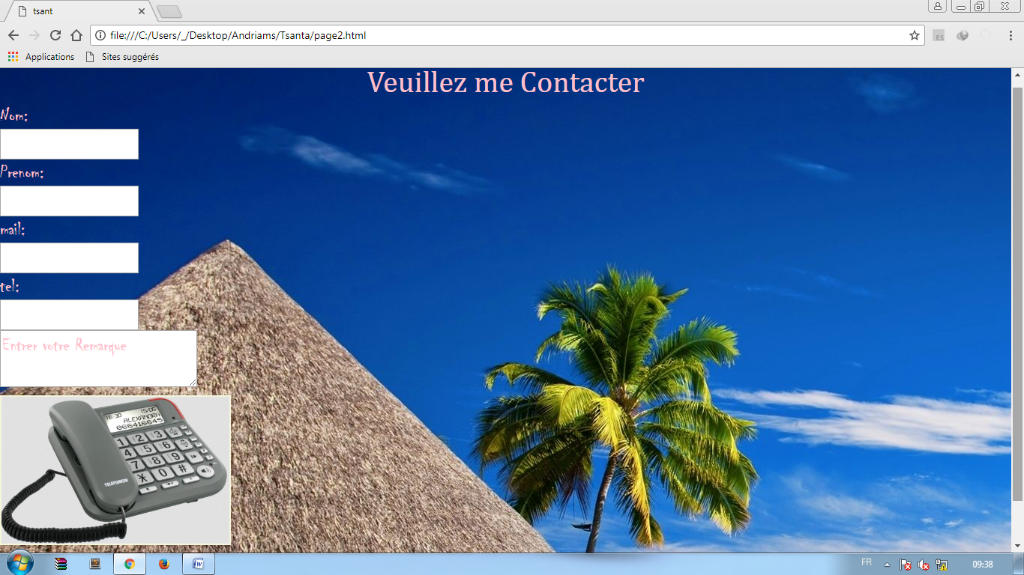

<! DOCTYPE html>

<Html>

<Head>

<Meta charset="utf-8">

<Title>tsant</title>

<link rel="stylesheet" type="text/css" href="assets/css/bootstrap.min.css">

<link rel="stylesheet" type="text/css" href="assets/css/style.css">

</head>

<Body>

<div class="titrr">Veuillez me Contacter</div>

<div class="zah">

Nom: <br><input type="text" name="" placeholder=""= "entrer votre nom"><br>

Prenom :< br><input type="text" name="" placeholder=""= "entrer votre prenom"><br>

mail: <br><input type="text" name="" placeholder=""= "entrer votre mail"><br>

tel :<br><input type="text" name="" placeholder=""= "entrer votre telefon"><br>

<div id="remm"><textarea cols="30px">Entrer votre Remarque</textarea></div>

</div>

<div id="srrr"><img src="./assets/img/finday.jpg"></div>

<a href="page1.html"><div id="retu">Retour</div></a>

</body>

</html>

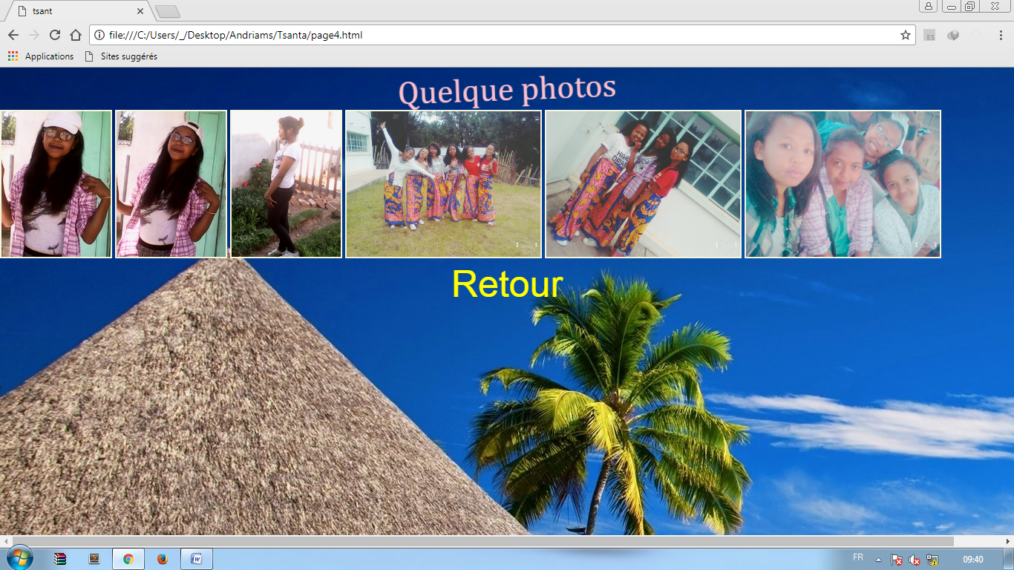

CODE

<! DOCTYPE html>

<Html>

<Head>

<Meta charset="utf-8">

<Title>tsant</title>

<link rel="stylesheet" type="text/css" href="assets/css/bootstrap.min.css">

<link rel="stylesheet" type="text/css" href="assets/css/style.css">

<link rel="stylesheet" type="text/css" href="assets/css/animate.css">

</head>

<Body>

<div class="qlq"> Quelque photo</div>

<div id="ssr" class="ssu">

<img src=".\assets\img\aa1.jpg"><img src=".\assets\img\aa2.jpg"> <img src=".\assets\img\nn5.jpg">

<img src=".\assets\img\ff1.jpg"><img src=".\assets\img\ff2.jpg"><img src=".\assets\img\tss.jpg">

</div>

<a href="page1.html"><div id="retu">Retour</div></a>

</body>

</html>

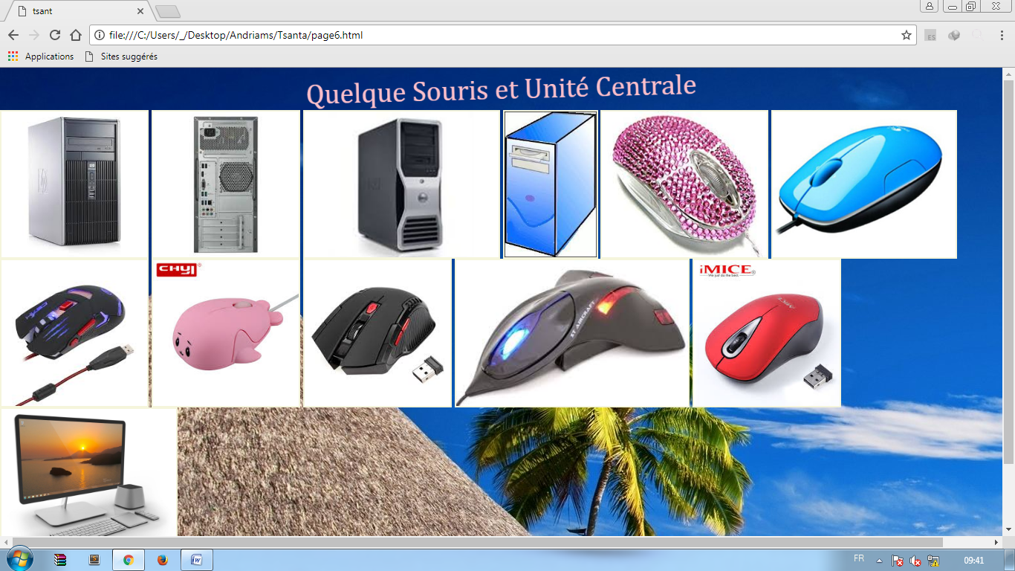

CODE

<! DOCTYPE html>

<Html>

<Head>

<Meta charset="utf-8">

<Title>tsant</title>

<link rel="stylesheet" type="text/css" href="assets/css/bootstrap.min.css">

<link rel="stylesheet" type="text/css" href="assets/css/style.css">

<link rel="stylesheet" type="text/css" href="assets/css/animate.css">

</head>

<body>

<div class="qlq">Quelque Souris et Unité Centrale</div>

<div id="ssr" class="ssu">

<img src=".\assets\img\uu1.jpg"><img src=".\assets\img\uu2.jpg"><img src=".\assets\img\uu3.jpg">

<img src=".\assets\img\uu4.jpg"><img src=".\assets\img\ss1.jpg"><img src=".\assets\img\ss2.jpg">

<img src=".\assets\img\ss4.jpg"><img src=".\assets\img\ss5.jpg"><img src=".\assets\img\ss6.jpg">

<img src=".\assets\img\ss7.jpg"><img src=".\assets\img\ss8.jpg"><img src=".\assets\img\ss9.jpg">

</div>

<a href="page1.html"><div id="retu">Retour</div></a>

</body>

</html>

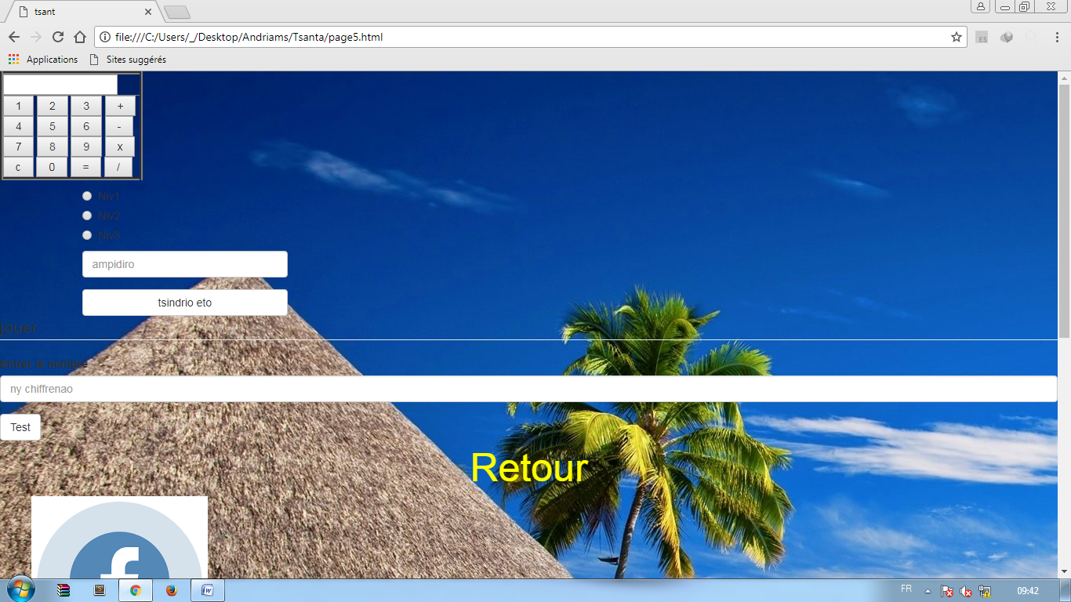

CODE

<!DOCTYPE html>

<html>

<head>

<meta charset="utf-8">

<title>tsant</title>

<link rel="stylesheet" type="text/css" href="assets/css/bootstrap.min.css">

<link rel="stylesheet" type="text/css" href="assets/css/style.css">

</head>

<body>

<div id="machine">

<FORM NAME="Calc">

<TABLE BORDER=4><TR><TD><INPUT TYPE="text" NAME="Input" Size="16"><br></TD></TR><TR><TD>

<INPUT TYPE="button" NAME="one" VALUE=" 1 " OnClick="Calc.Input.value += '1'">

<INPUT TYPE="button" NAME="two" VALUE=" 2 " OnCLick="Calc.Input.value += '2'">

<INPUT TYPE="button" NAME="three" VALUE=" 3 " OnClick="Calc.Input.value += '3'">

<INPUT TYPE="button" NAME="plus" VALUE=" + " OnClick="Calc.Input.value += ' + '"><br>

<INPUT TYPE="button" NAME="four" VALUE=" 4 " OnClick="Calc.Input.value += '4'">

<INPUT TYPE="button" NAME="five" VALUE=" 5 " OnCLick="Calc.Input.value += '5'">

<INPUT TYPE="button" NAME="six" VALUE=" 6 " OnClick="Calc.Input.value += '6'">

<INPUT TYPE="button" NAME="minus" VALUE=" - " OnClick="Calc.Input.value += ' - '"><br>

<INPUT TYPE="button" NAME="seven" VALUE=" 7 " OnClick="Calc.Input.value += '7'">

<INPUT TYPE="button" NAME="eight" VALUE=" 8 " OnCLick="Calc.Input.value += '8'">

<INPUT TYPE="button" NAME="nine" VALUE=" 9 " OnClick="Calc.Input.value += '9'">

<INPUT TYPE="button" NAME="times" VALUE=" x " OnClick="Calc.Input.value += ' * '"><br>

<INPUT TYPE="button" NAME="clear" VALUE=" c " OnClick="Calc.Input.value = ''">

<INPUT TYPE="button" NAME="zero» VALUE=« 0» OnClick="Calc.Input.value += '0'">

<INPUT TYPE="button" NAME="DoIt» VALUE=« = " OnClick="Calc.Input.value = eval (Calc.Input.value)">

<INPUT TYPE="button" NAME="div" VALUE=« /» OnClick="Calc.Input.value += ' / '"><br></TD></TR></TABLE></FORM>

</div>

<div class="container">

<div class="row">

<div class="col-md-3 col-md-offest-3">

<div class="form-group">

<div class="radio"><label><input type="radio" name="optradio" id="niv1" value="niv1">Niv1</label></div>

<div class="radio"><label><input type="radio" name="optradio" id="niv2" value="niv2">Niv2</label></div>

<div class="radio"><label><input type="radio" name="optradio" id="niv3" value="niv3">Niv3</label></div>

<input type="number" class="form-control" id="nbr" placeholder="ampidiro">

</div>

<button class="btn btn-default btn-block" id="btn">tsindrio eto </button>

<div id="resultat"></div>

</div>

</div>

</div>

<Fieldset><legend>jouer</legend>

<div class="form-group">

<label for="tl">Entrer le nombre</label>

<input type="number" class="form-control" id="tl" placeholder= "ny chiffrenao">

</div>

</fieldset>

<button class="btn btn-default btn-blok" id="ko">Test</button>

<script type="text/javascript" src="assets/js/app.js"></script>

<a href="page1.html"><div id="retu">Retour</div></a>

</body>

</html>

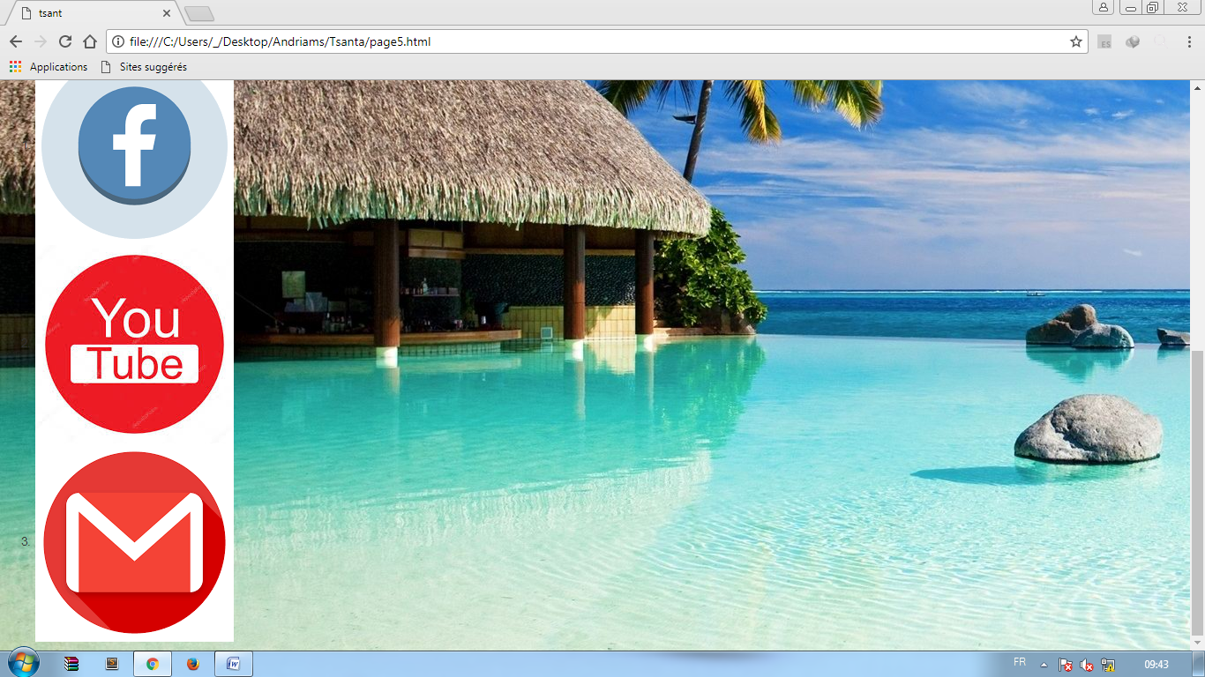

CODE

<ol class="lli">

<li class="a"><a href="http://www.facebook.com">

<img src="./assets/img/fbb.png"></a></li>

<li class="a"><a href="http://www.youtube.com">

<img src="./assets/img/yuu.jpg"></a></li>

<li class="a"><a href="http://www.gmail.com">

<img src="./assets/img/mmm.png"></a></li>

</ol>

EXPLICATION DES SYMBOLES SUR LES PHOTOS

✌ : Position des images ou des écritures

🌢: Couleur du background ou des écritures

🖐: (font-size) taille de la police

☹: (font-family) de la police

⧫:width (longueur de la largeur)

⚫:heigth (longueur de l’hauteur )

EXPLICATION DES CODES

<!DOCTYPE html>= html5

<html> = balise html

<head> = en tête

<title></title>

</head>

<body> = contenu de la page

</body>

</html>